Project 4

1. **Design cpmFs:**

The objective of the project was to create a file system that can perform read and write operation on the file. The implementation of file system starts with the creation of a disk of size 256 blocks which contains 1024 bytes each. The Block 0 reserved for the Directory which consists of 32 bytes extents. The first bytes is a binary bytes which verify the existence of extent. Followed by next eight bytes is reserved for file name which is followed by additional 3 bytes that hold the file extension. And renaming blocks hold the data.   
In this project, to create a file system several steps were followed. First, step was to read the file and gather the file information using file system and so on.

Here is a snap shot of the implementation of the file system.

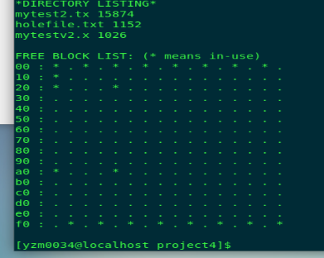

1. **Lesson Learned:**
2. I gain a lot experience in coding in C, since C is not my primary coding language I lost my skills in C which I recovered with this course.
3. I get to know about the basic working of file system and functionality of directory in the system.
4. I also learned the use of image file in the file system.